How to segregate the ‘.extension’ files

1. Create 1 dataset similarly as previous one for the get meta data activity from inbound folder
2. Then create 1 more dataset using inbound folder but add parameter for file name using add dynamic content
3. Then create one more dataset for outbound folder but in place of folder use concat function outbound/ the variable

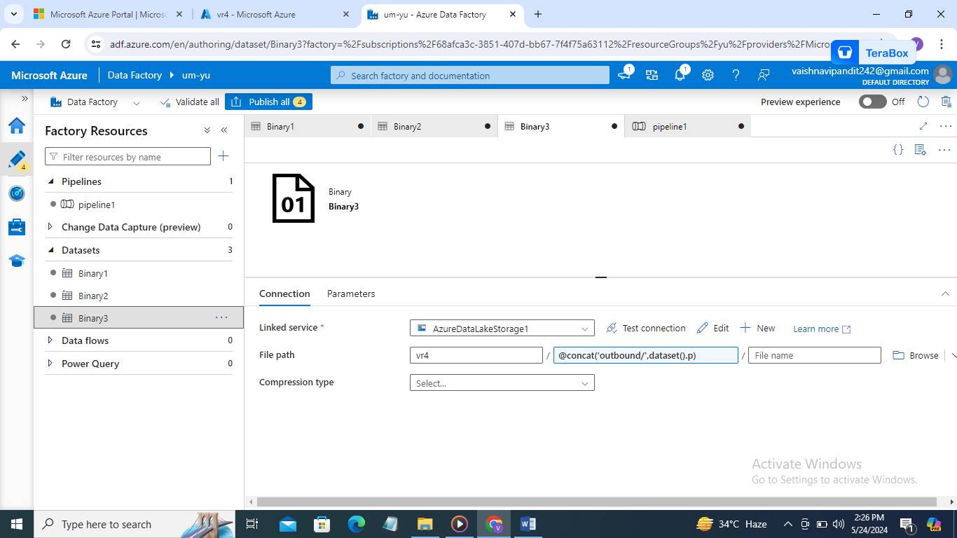

1. Now create get meta data activity to get child items from source dataset one
2. Send it to the for each activity
3. In for each activity
4. Got to setting select sequential and in items select get meta data activity childitems output

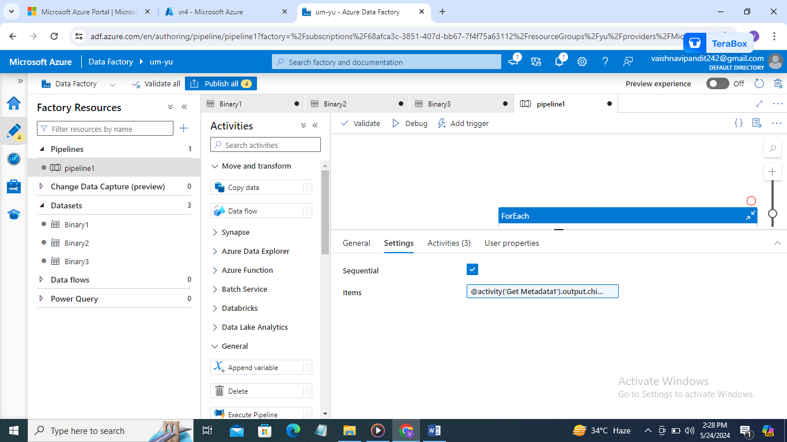

1. Now in for each activity create set activity for variable filename and add value as for each output.name

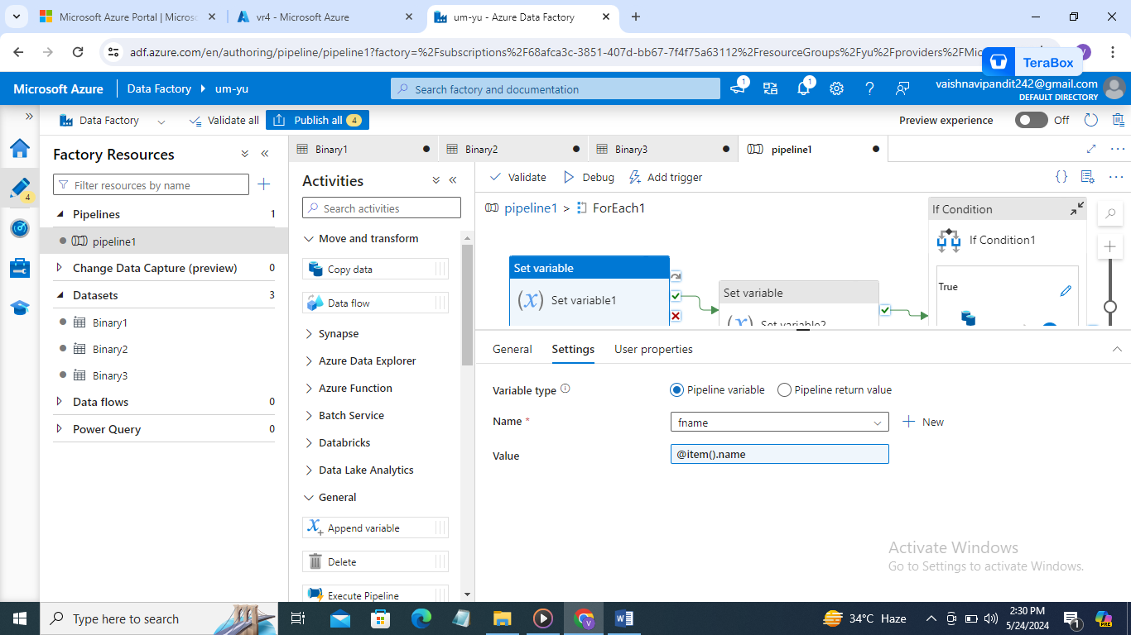

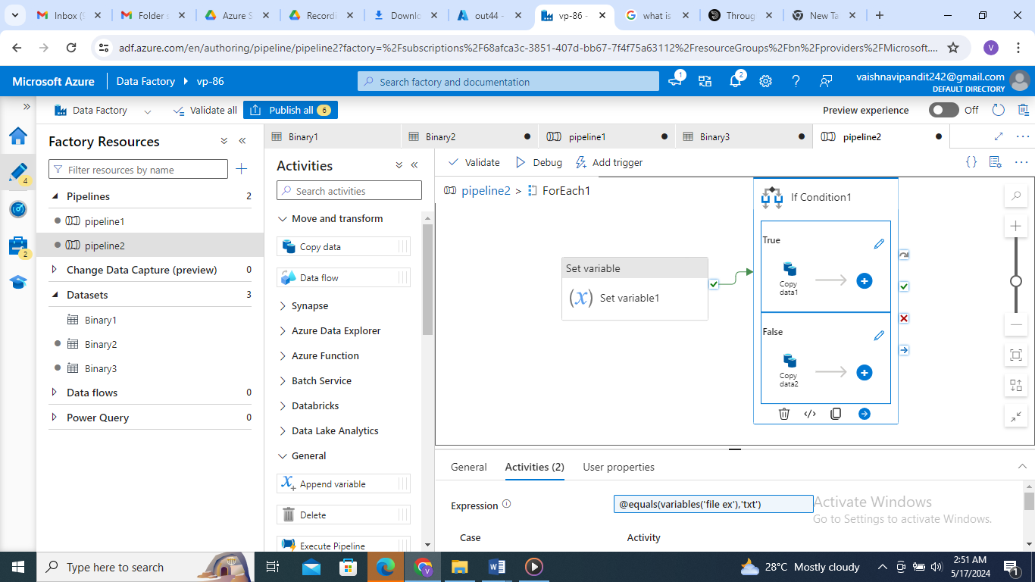

1. Then add the another set variable activity to get file extension for that use split function

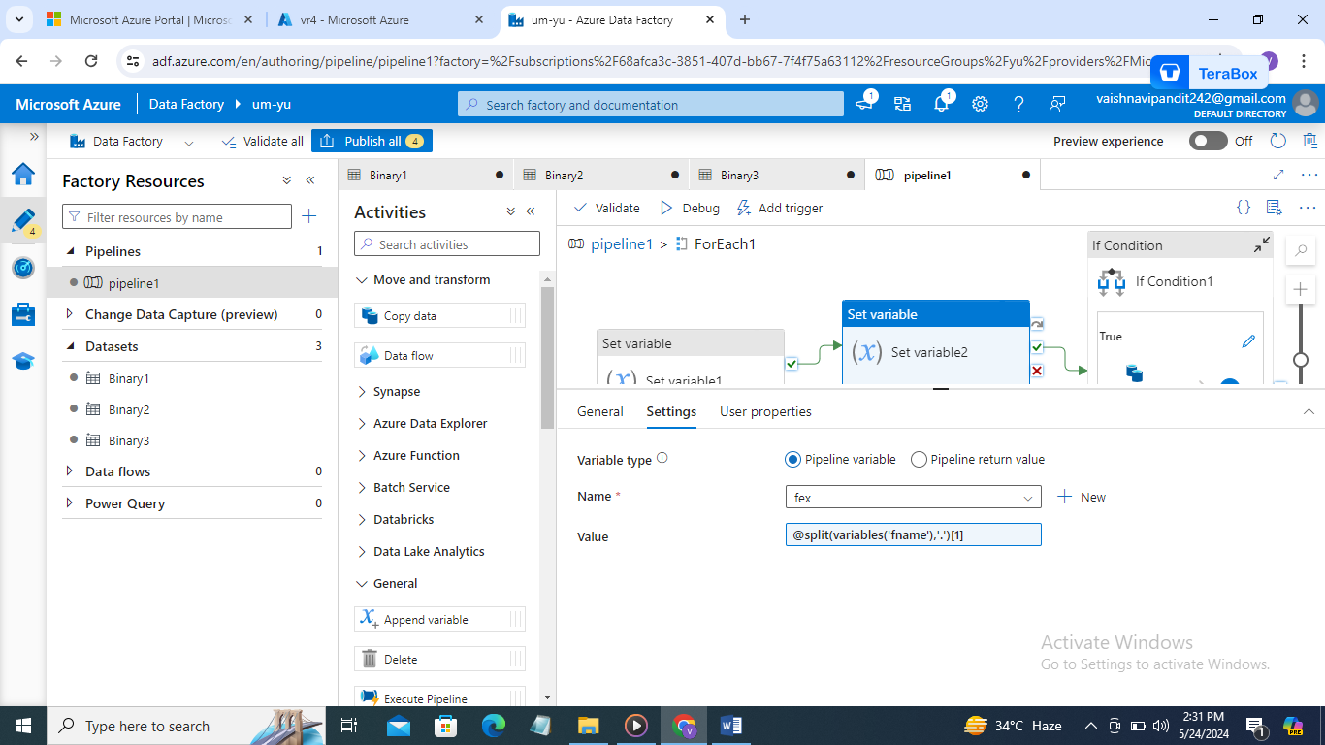

1. Now add if condition in expression select function equals add ‘csv’, file extension variable

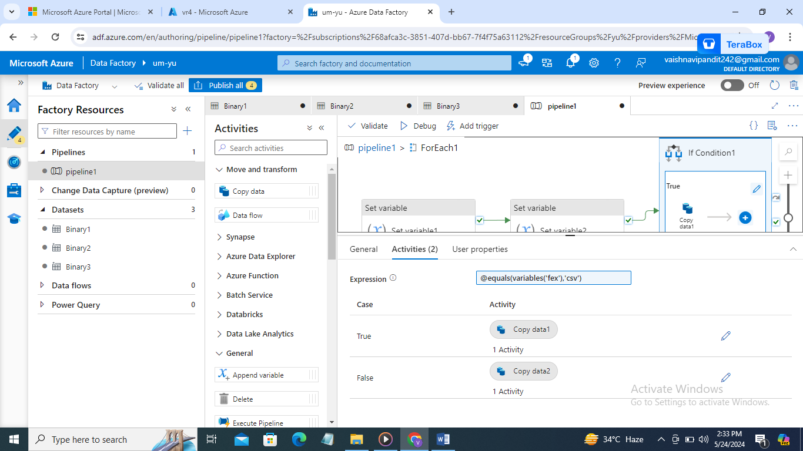

1. Now create two copy activities in true and second in false

In true -> copy activity add source as second dataset and in value at file name add variable filename

And in sink select dataset 3 and add the parameter value as csv

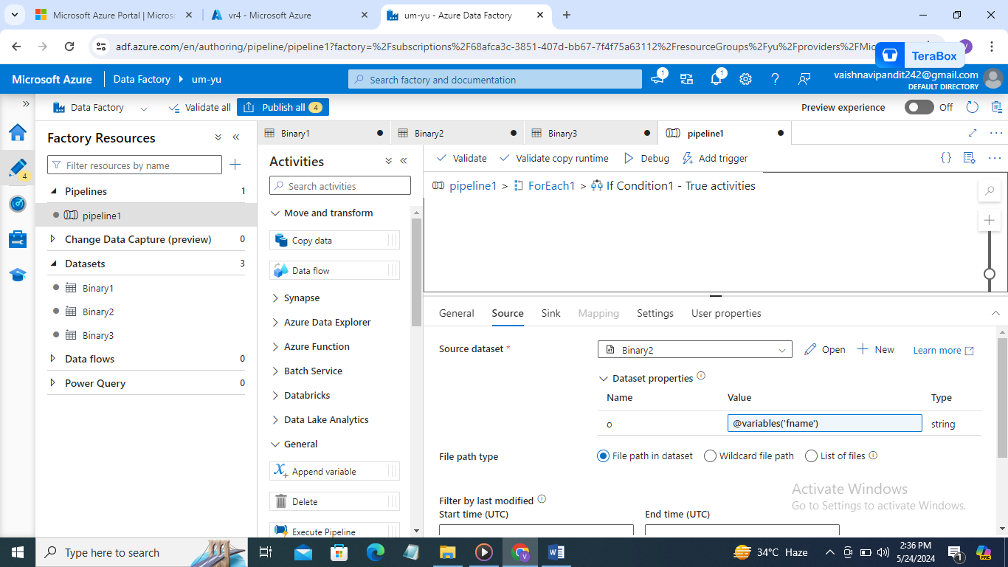

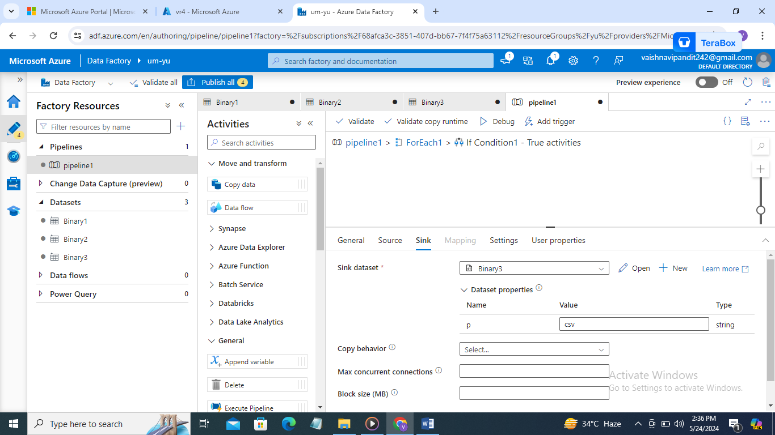

1. In false copy activity add the source as dataset 2 and add value as filename and in sink add dataset 3 and value as folder name json

